This report analyses data from the Baseline Study conducted for the Transforming Education for Girls in Nigeria and Tanzania (TEGINT) project in Nigeria and Tanzania between 2007 and 2009. TEGINT is a Special Initiative begun in 2007 as a partnership between ActionAid, Maarifa ni Ufunguo (Maarifa) in Tanzania, and Community Action for Popular Participation (CAPP) in Nigeria funded by Comic Relief and the Tubney Charitable Trust. The overarching objectives of the Baseline Study were to:

i) Identify key aspects of gender, education and socio-economic context in the districts/states in which the TEGINT project works;
ii) Outline gender patterns on enrolment, attendance and progression in the schools in which TEGINT is operating;
iii) Identify key gender aspects of school processes in the schools in which TEGINT is operating;
iv) Assess forms of mobilisation that have taken place to support girls’ access to and progression through the schools in which TEGINT is operating;
v) Analyse views on obstacles to girls’ education and how to overcome them;
vi) Assess the implications of findings from the baseline research for future work in TEGINT.
Building from the TEGINT conceptual framework (Section 2.3), which is concerned with girls’ views on the obstacles and strategies to advancing their education, the Study also set out to document the numbers of girls, boys and teachers in schools and to explore aspects of gendered power relations experienced by girls and boys at school.
Data was collected from survey interviews and questionnaires distributed to 1,053 respondents from 57 schools in six districts of Northern Tanzania and 1,735 respondents from 72 schools in eight states of Northern Nigeria in 2008. Follow-up in-depth interviews were carried out at 14 schools in Tanzania and 16 schools in Nigeria in 2009. Administrative data from school records was collated in 2008 and 2009 and a range of observations were made of school facilities.
Key findings
The objectives of the Study were formulated into key areas of investigation for the researchers, or aims, under which findings were generated by country. The findings and data are discussed in detail in the main report.
Aim 1: What girls say about aspirations, obstacles and ideas for change
Girls have high aspirations for their education in both Northern Tanzania and Northern Nigeria. Girls in both settings identify a broad range of obstacles and solutions to achieving these educational aspirations. In Tanzania, girls’ responses regarding solutions tend to focus on short-term and less sustainable interventions, like sponsorship to pay school fees, whilst girls in Nigeria suggest a broader range including more political solutions such as stopping fees and levies. However, there is much variation in girls’ views in both contexts in different schools and districts or states and the detail of these relationships emerges in the findings for other research aims.
Aim 2: Comparing the schools where TEGINT is working and other schools in the districts or states
Gender gaps in enrolment have virtually closed in the schools in which the project is working in Tanzania but they remain in Nigeria. There is a similar pattern in attainment although actual pass rates are higher overall in Nigeria. This may be because a lower proportion of girls actually reach the end of Junior Secondary School in Nigeria than primary school in Tanzania, hence the population eligible for exams is smaller. In both contexts the TEGINT project is working in schools with slightly higher gender parity in enrolment and attainment than the state or district

averages, but not in all cases. However, gender gaps in all locations are higher than national rates. There are large variations in the size of the gender gaps in different districts and states, but these did not necessarily relate to overall poverty indicators. There are minor urban-rural differences. Much school-level data was missing or poor quality in the Nigerian schools, making it difficult to monitor, assess and act on gender gaps and the problems of girls’ and boys’ attendance, progression and attainment.
Aim 3: School conditions and what girls say about them
Girls’ capacity to voice concerns about education was most evident in schools that had the smallest gender gaps in enrolment, attendance, progression and completion. In both countries a strikingly higher proportion of girls living in areas of lower poverty but higher inequality (particularly districts/states with large urban areas) articulate a wider range of concerns and cite the more political strategies than girls living in areas of absolute poverty. This suggests that whether or not girls are able to give voice to educational problems and solutions depends on particular contextual features of the communities in which they live, the levels of gender inclusiveness of the schools, and the extent to which more critical views may or may not be tolerated. It suggests that girls being able to see alternatives may be very important in expanding their critical awareness and ability to strategise for solutions.
Aim 4: Teacher qualifications, girls’ progression and attainment, and perceptions of schooling
Better trained teachers are associated with girls speaking out more about obstacles to completing their education and possible solutions. In Nigerian states with more economic, political and educational opportunities for women, girls are more able to articulate a wider range of demands for their schooling. Higher proportions of female teachers and lower pupil-teacher ratios are associated with reduced gender parity in enrolment, attendance, progression and attainment in the project schools in Tanzania, but not in Nigeria.
Aim 5: Payments demanded by schools and links to girls’ views and levels of attainment
Despite the existence of legal and policy frameworks in Nigeria and Tanzania to ensure free schooling, basic education is not free. A range of levies are charged with wide disparities between schools, states and districts. In Nigeria a clear link between levies and girls’ dropping out of school was documented. Higher levies are charged in schools with the biggest gender gaps. Girls talked of missing school to avoid the humiliation of being unable to pay and corporal punishment. Some girls work in the market to earn the funds which will allow them back to school. In both countries government funding is insufficient. In Tanzania the schools with smallest gender gaps are getting the least government funding but charging the highest levies. In Nigeria, government allocations are associated with state and local political networks.
Aim 6: School Management Committees / Parent Teacher Associations and support for girls’ attainment and capacity to speak out
School committees are more established in Tanzania than Nigeria, with a longer history and clearer mandate within decentralised governance structures. This is reflected in action taken on gender, with committees in Tanzania reporting a wider range of activities in support of girls’ education. Women are underrepresented on school committees in Tanzania, but much more so in Nigeria where many committees have no female membership. Higher levels of female membership seem to translate into higher gender parity in enrolment, attendance, progression and completion at schools in Tanzania, with a weaker relationship in Nigeria, perhaps because so many committees were not active at the time of the Study.
Aim 7: Gender, generation and school-community gap
There are troubling silences and a lack of understanding on the part of some teachers, school committees, village leaders and parents of the levels of violence girls are exposed to and the effects of poverty on children’s schooling. Girls experience multiple forms of violence, including corporal and other humiliating punishments at school, sexual

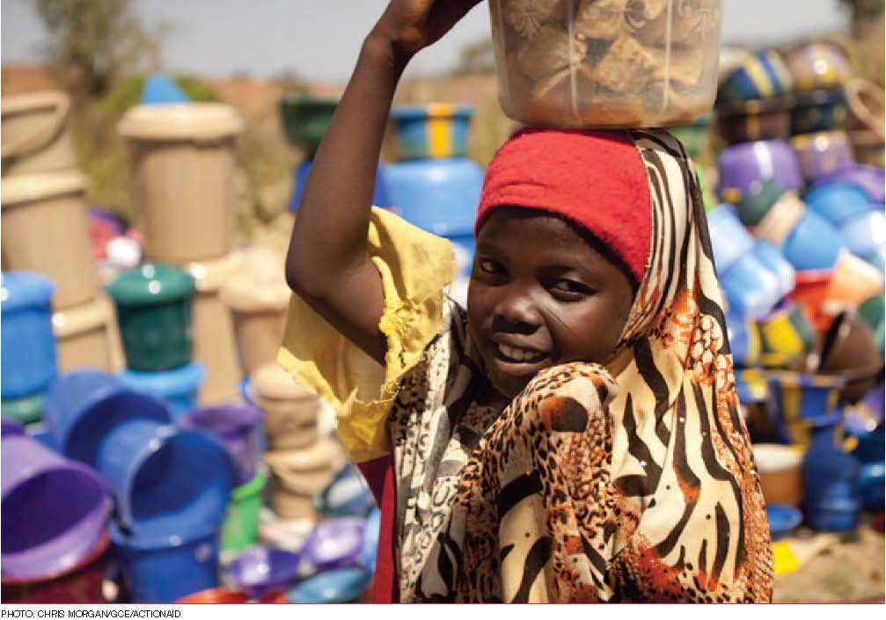
harassment and coerced sex in exchange for money or goods which are sometimes needed to pay for the costs of schooling. In both contexts there was a denial by many head teachers and other officials of violence taking place in schools. They lack knowledge on actions to take and any that are taken are rarely in the girls’ best interests. Head teachers seem to be aware that actions are inadequate, particularly in Tanzania, but linkages are weak between schools and communities and reporting systems are largely ineffective. Girls’ views on major obstacles in completing their education are not shared by all the adults and communities who manage and teach in the schools they attend.

Next steps
The data from the Baseline Study emphasises that the TEGINT project is working in complex local environments and the picture of girls’ education is different in particular locations associated with school and community conditions. The research confirms the importance of particular strategic interventions concerned with teacher education and expanding girls’ horizons pointing to a need for further investigation into approaches to working in a sustained and strategic way at multiple levels with teachers, parents, school committees, communities, local government and, crucially, girls themselves to transform their education. It highlights the importance of in-school and out-of-school approaches to bring about significant change for gender equality. Recommendations for the project developed collaboratively by project teams, indicated particular interventions, discussions and forms of mobilisation needed.
Responding to this Baseline Study, TEGINT in 2011 will undertake in-depth qualitative case studies on the relationship between levies, early marriage and experiences of violence to girls’ drop out from school (Nigeria) and how School Management Committees’ engagement with gender issues contributes to girls’ retention and progression in school and their empowerment (Tanzania).

